1. Working with numbers looks easy but it’s not easy. Be careful.
2. By default numbers are stored as double in MongoDB. But if you want to store as 32-bit integer or 64-bit integer, then we need to pass type info along with number.
3. 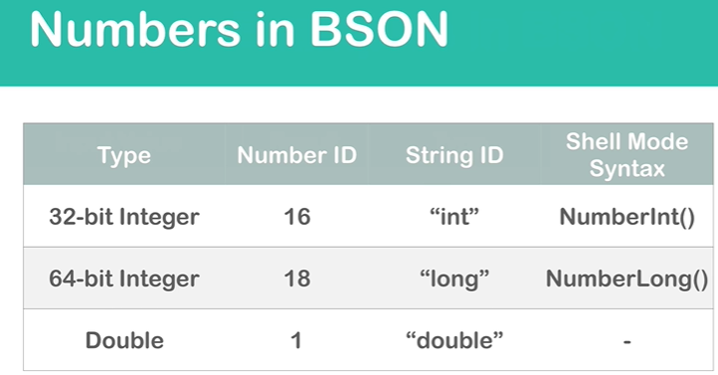
4. 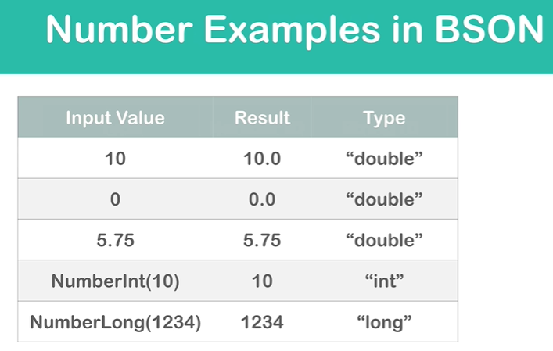
5. 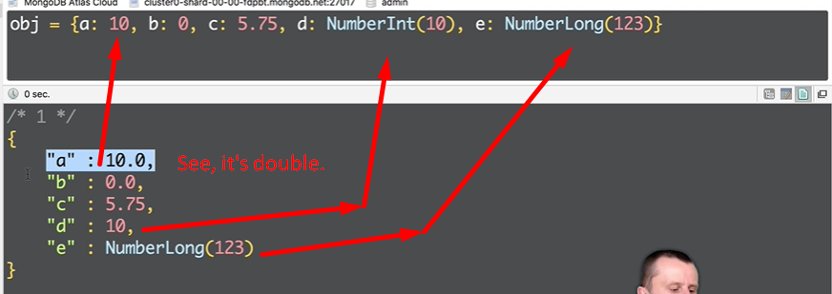
6. 